**Task – 25/09/2020**

**Task 1 : Create server which will run on port 5000**

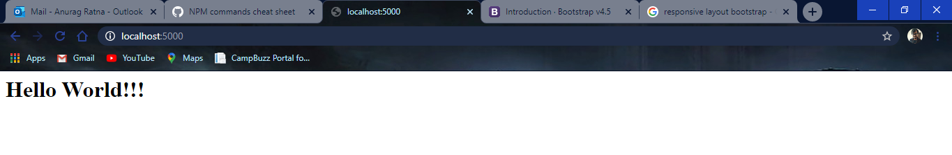

server1.js  
-------------------------------------------------------------------------------------------------------------------------------------

var http = require('http')

http.createServer(function(request,response){

    response.writeHead(200)

    response.write(`<h1>Hello World!!!</h1>`);

    response.end()

}).listen(5000);

console.log('Server running at http://localhost:5000')

-------------------------------------------------------------------------------------------------------------------------------------

**Task 2 :**

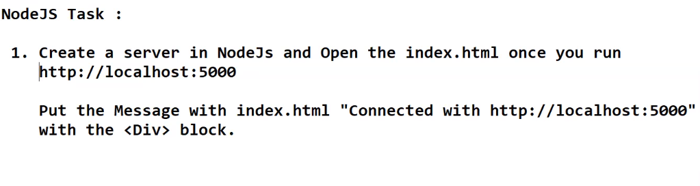

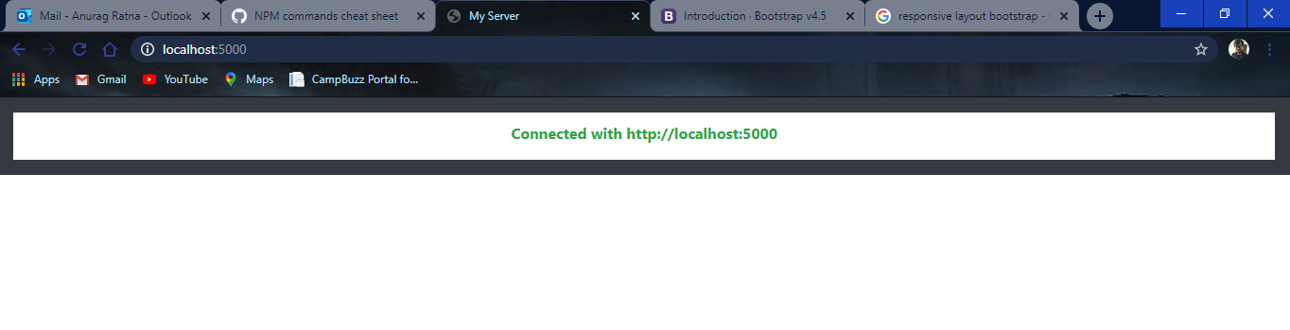

server2.js  
-------------------------------------------------------------------------------------------------------------------------------------

const { fstat } = require('fs');

var http = require('http')

var fs = require('fs')

http.createServer(function(request,response){

    fs.readFile('index.html',function(err,data){

        if(err){

            response.writeHead(404)

            response.write(err)

            response.end()

        }

        else{

            response.writeHead(200)

            response.write(data);

            response.end();

        }

    })

}).listen(5000);

console.log('Server running at http://localhost:5000')

-------------------------------------------------------------------------------------------------------------------------------------

Index.html  
-------------------------------------------------------------------------------------------------------------------------------------

<!DOCTYPE html>

<html>

    <head>

        <meta charset="utf-8">

        <title>My Server</title>

        <meta name="viewport" content="width=device-width, initial-scale=1">

        <link href="https://fonts.googleapis.com/css?family=Open+Sans:300,300i,400,400i,600,600i,700,700i|Montserrat:300,400,500,700" rel="stylesheet">

        <link rel="stylesheet" href="https://stackpath.bootstrapcdn.com/bootstrap/4.5.2/css/bootstrap.min.css" integrity="sha384-JcKb8q3iqJ61gNV9KGb8thSsNjpSL0n8PARn9HuZOnIxN0hoP+VmmDGMN5t9UJ0Z" crossorigin="anonymous">

    </head>

    <body>

        <div class="p-3 mb-2 bg-dark text-white">

            <div class="d-flex justify-content-center bg-white" style="padding-top: 10px">

                <p class="text-success font-weight-bold">Connected with http://localhost:5000</p>

            </div>

        </div>

    </body>

</html>

**Task 3 : Perform Module Export**

data.js  
-------------------------------------------------------------------------------------------------------------------------------------

module.exports = {

    fName:'James',

    lName:'Bond'

}

-------------------------------------------------------------------------------------------------------------------------------------

app.js  
-------------------------------------------------------------------------------------------------------------------------------------

var person = require('./data.js')

console.log(person.fName+' '+person.lName)

-------------------------------------------------------------------------------------------------------------------------------------

Output:  
-------------------------------------------------------------------------------------------------------------------------------------



-------------------------------------------------------------------------------------------------------------------------------------

**Task 4 : Perform writeFile**

app.js  
-------------------------------------------------------------------------------------------------------------------------------------

var fs = require('fs')

fs.writeFile('test1.txt','Hello World!!!',function(err){

    if(err) console.log(err)

    else console.log('Write operation complete')

})

-------------------------------------------------------------------------------------------------------------------------------------

**Task 5 : Perform file deletion**

app.js  
-------------------------------------------------------------------------------------------------------------------------------------

var fs = require('fs')

fs.unlink('f1.txt',function(){

    console.log('Delete operation complete')

})

-------------------------------------------------------------------------------------------------------------------------------------

**Task 6 : perform routing by changing url**

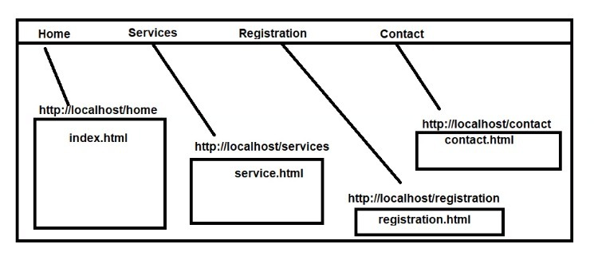

app.js  
-------------------------------------------------------------------------------------------------------------------------------------

var http = require('http')

var url = require('url')

var fs = require('fs')

var server = http.createServer(function(request,response){

    var path = url.parse(request.url).pathname

    switch(path){

        case '/':

            fs.readFile('index.html',function(err,data){

                if(err){

                    response.writeHead(404)

                    response.write(err)

                }

                else {

                    response.writeHead(200)

                    response.write(data)

                }

                response.end()

            })

            break

        case '/services':

            fs.readFile('services.html',function(err,data){

                if(err){

                    response.writeHead(404)

                    response.write(err)

                }

                else {

                    response.writeHead(200)

                    response.write(data)

                }

                response.end()

            })

            break

        case '/registration':

            fs.readFile('registration.html',function(err,data){

                if(err){

                    response.writeHead(404)

                    response.write(err)

                }

                else {

                    response.writeHead(200)

                    response.write(data)

                }

                response.end()

            })

            break

        case '/contact':

            fs.readFile('contact.html',function(err,data){

                if(err){

                    response.writeHead(404)

                    response.write(err)

                }

                else {

                    response.writeHead(200)

                    response.write(data)

                }

                response.end()

            })

            break

        default:

            response.writeHead(404);

            response.write("opps this doesn't exist - 404");

            response.end();

            break;

    }

})

server.listen(5000)

-------------------------------------------------------------------------------------------------------------------------------------